**THE ARTBOOK**

**First Sketches**

**Screens**

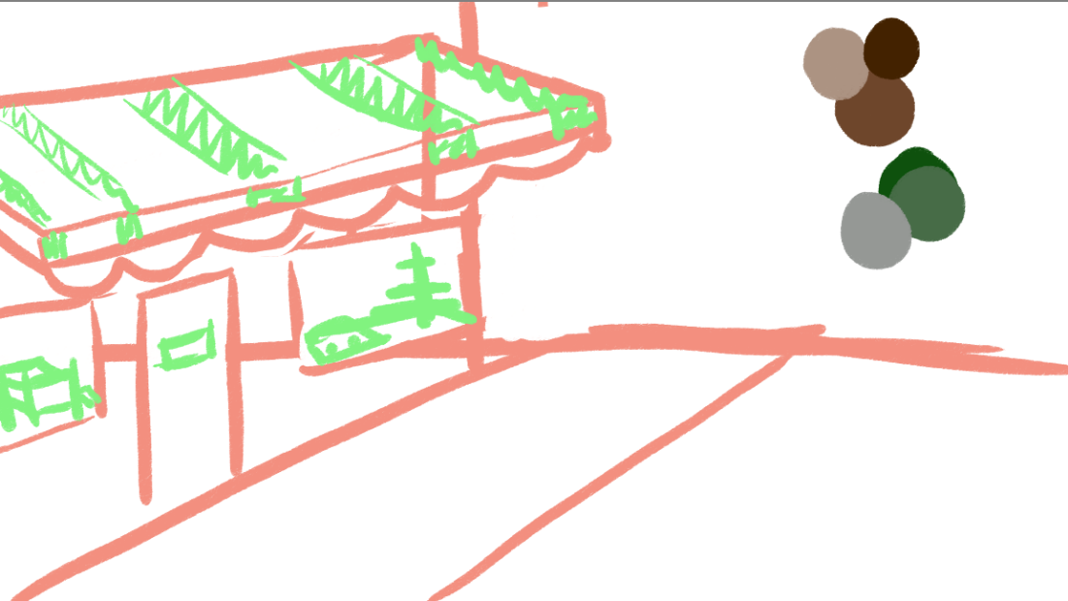

**Characters**

**Minigames & Items**

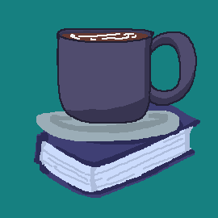

**Screenshots**

